Software Requirements Specification
for
Design Pattern Management Plugin
Version 1.5 approved
Prepared by Hoang Nguyen Nhat Tao
National University of Singapore
8th July 2011
Table of Contents
Table of Contents ii
Revision History iv
1. Introduction 1
1.1 Purpose 1
1.2 Document Conventions 1
1.3 Intended Audience and Reading Suggestions 1
1.4 Product Scope 1
1.5 References 1
2. Overall Description 2
2.1 Product Perspective 2
2.2 Product Functions 2
2.3 User Classes and Characteristics 3
2.4 Operating Environment 3
2.5 Design and Implementation Constraints 3
2.6 User Documentation 3
2.7 Assumptions and Dependencies 3
3. External Interface Requirements 4
3.1 User Interfaces 4
3.2 Hardware Interfaces 6
3.3 Software Interfaces 6
3.4 Communications Interfaces 7
4. System Features 7
4.1 Add new Design Pattern Instance 7
4.2 Assign Design Pattern Instance to a Location 7
4.3 Remove Design Pattern Instance 8
4.4 Rename Design Pattern Instance 8
4.5 Edit Design Pattern Instance 8
5. Other Nonfunctional Requirements 9
5.1 Performance Requirements 9
5.2 Safety Requirements 9
5.3 Security Requirements 9
5.4 Software Quality Attributes 9
5.5 Business Rules 10
6. Other Requirements 10
Appendix A: Glossary 10
Appendix B: Analysis Models 10
Appendix C: To Be Determined List 10

Revision History
Name | Date | Reason For Changes | Version
Hoang Nguyen Nhat Tao | 29/05/2011 | First draft | 1.0
Hoang Nguyen Nhat Tao | 08/07/2011 | Revise requirements | 1.5

Introduction

Purpose
This document provides an insight into basic requirements and functionalities of Design Pattern Management Plugin version 1.0.

Document Conventions
DPMP = Design Pattern Management Plugin
XVCL = XML-based Variant Configuration Language
MVVM = Model-View-ViewModel

Intended Audience and Reading Suggestions
This document is intended for readers who have basic knowledge about XVCL and design patterns.

Product Scope
DPMP allows .NET developers to utilize design patterns efficiently for projects in Visual Studio 2010. Besides the built-in library of design pattern models, developers can create a new design pattern model and then customize into specific design pattern instances for different projects.

When developers modify a design pattern model, according modifications will automatically be made to all design pattern instances generated from that model. In addition, any design pattern instance can be reused for different projects. DPMP save developers a lot of time because they can make changes once for multiple projects.

DPMP is developed in C# .NET 4.0 using Visual Studio 2010 SDK. Microsoft SQL Server Compact 4.0 is used as the portable storage engine for DPMP, storing all design pattern models and instances.

This version 1.0 focuses on developing DPMP to be correctly functional. The graphical user interface will be improved in later versions.

References
1. (n.d.). Retrieved from XML- Based Variant Configuration Language - Technology for Reuse: http://xvcl.comp.nus.edu.sg/overview_technical_a.php
2. (n.d.). Retrieved from Microsoft .NET Framework 4.0: http://www.microsoft.com/downloads/en/details.aspx?familyid=9cfb2d51-5ff4-4491-b0e5-b386f32c0992
3. (n.d.). Retrieved from IEEE Software Requirements Specification Template: www.csc.villanova.edu/~tway/courses/csc4181/srs_template-1.doc
4. Arvind, G. (2010). Reuse and Maintainace of Design Pattern Code using XVCL - B.Comp.Dissertation. National University of Singapore.
5. (2011). Introduction to Model View ViewModel and Line of Business Applications. In R. Garofalo, Building Enterprise Applications with WPF and the MVVM (pp. 1-23). Microsoft Press.
6. MDSN. (n.d.). Retrieved from ADO.NET Entity Framework: http://msdn.microsoft.com/en-us/library/bb399572.aspx
7. (2010). Extending Visual Studio. In M. Snell, & L. Powers, Microsoft Visual Studio 2010 Unleashed (pp. 507-663). Pearson Education, Inc.

Overall Description

Product Perspective
DPMP follows up the ideas of representing design patterns in XVCL of Mr. Arvind in his B.Comp.Dissertation. By means of Visual Studio 2010 SDK, it will be developed as an extension for Visual Studio 2010.

Product Functions
The main functionalities of DPMP include:

- Ability to add new design pattern instances to a specific design pattern model
- Ability to edit or remove design pattern instances
- Ability to rename design pattern instances
- Ability to assign one design pattern instance to multiple projects in Visual Studio
- Ability to auto-propagate changes to related design pattern instances when a design pattern model is updated
- Ability to auto- propagate changes to corresponding projects when a design pattern instance is updated

User Classes and Characteristics
DPMP mainly targets at .NET developers who need use design patterns regularly. DPMP will save them from writing redundant codes and making error-prone changes. However, developers should at least have some basic knowledge of XVCL in order to use DPMP.

Operating Environment
2.4.1. Software Requirements
- Window XP SP3 or newer
- Microsoft .NET Framework 4.0
- Visual Studio 2010
- Java Runtime Environment (JRE) 1.6

2.4.2. Hardware Requirements
No special hardware limitation

Design and Implementation Constraints
DPMP has the following constraints:
- If user manually updates or removes any design pattern instance in a project, the design pattern management database will not be automatically updated accordingly.
- Any update to design pattern model or instance through DPMP will overwrite manual update by user.
- User cannot create multiple design pattern instances of the same name within a design pattern model.
- User cannot assign multiple design pattern instances of the same name to a project.

User Documentation
User guide and developer guide will be included.

Assumptions and Dependencies
DPMP depends on XVCL processor to generate design pattern instance. The XVCL processor can be downloaded at http://sourceforge.net/projects/fxvcl/files/.

External Interface Requirements

User Interfaces
User interface of DPMP will be developed using WPF 4.0, which utilizes data binding and allows more flexibility in design.

The design pattern management window roughly looks like this:

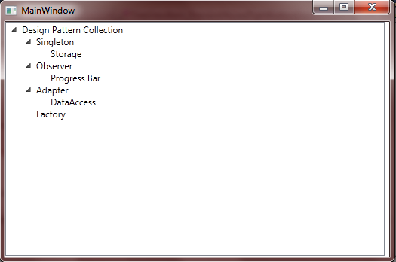
Figure 1: Design Pattern Management Window Prototype
The design pattern models and instances are represented hierarchically with one design pattern model having multiple design pattern instances.

Context menu is utilized to perform actions such as adding, editing or removing design pattern models and instances:

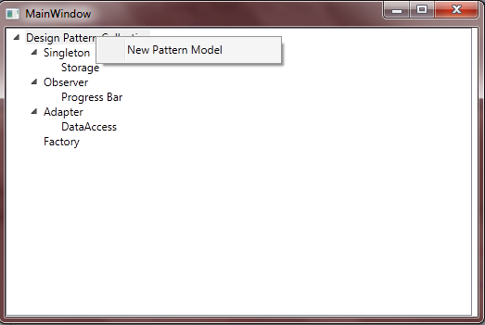
Figure 2: Context Menu Prototype to add new Design Pattern Model

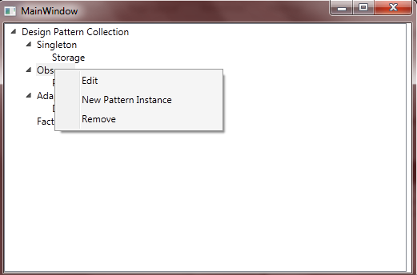
Figure 3: Context Menu Prototype for each Design Pattern Model
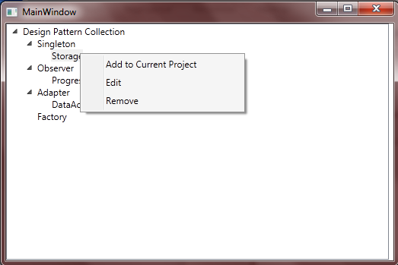
Figure 4: Context Menu Prototype for each Design Pattern Instance

Hardware Interfaces
Not Applicable

Software Interfaces

Database and Data Access
- Microsoft SQL Server Compact 4.0
- ADO .NET Entity Framework 4 with Entity Data Model

XVCL Processor:
- XVCL Processor version 3.2.3

Development Tools Environment (DTE)
- Library used to access Visual Studio Components such as Text Editor, Solution Explorer, Menus, etc
- Having different assemblies EnvDTE, EnvDTE80, EnvDTE90, EnvDTE100
- Available in Visual Studio 2010 SDK

Communications Interfaces
Not Applicable

System Features

Add new Design Pattern Instance
4.1.1 Description and Priority
Allow user to add new design pattern instance for a design pattern model. Priority: High
4.1.2 Stimulus/Response Sequences
1. User chooses to add new design pattern instance to a design pattern model.
2. DPMP asks for instance name.
3. User enters instance name.
4. DPMP assign pattern instance to current project and refreshes the UI.
4.1.3 Functional Requirements
REQ-1: DPMP Window has been started.
REQ-2: The pattern model contains no instance of the same name.

Assign Design Pattern Instance to a Location
4.2.1 Description and Priority
Allow user to assign a design pattern instance to a location. Priority: High
4.2.2 Stimulus/Response Sequences
1. User chooses a pattern instance to assign.
2. DPMP asks user for the location.
3. User specifies the location.
4. DPMP assigns the pattern instance to the location.
4.2.3 Functional Requirements
REQ-1: DPMP Window has been started.
REQ-2: The specified location contains no pattern instance of the same name.

Remove Design Pattern Instance
4.3.1 Description and Priority
Allow user to remove a design pattern instance from its pattern model. Priority: High
4.3.2 Stimulus/Response Sequences
1. User chooses a design pattern instance to remove.
2. DPMP asks user for confirmation.
3. User confirms to remove the pattern instance.
4. DPMP removes the pattern instance from containing projects and refreshes the UI.
4.3.3 Functional Requirements
REQ-1: DPMP Window has been started.
REQ-2: There is some design pattern instance to remove.

Rename Design Pattern Instance
4.4.1 Description and Priority
Allow user to rename a design pattern instance in the built-in library. Priority: High
4.4.2 Stimulus/Response Sequences
1. User chooses a design pattern instance to rename.
2. DPMP asks user for new name.
3. User enters new name for the pattern instance.
4. DPMP propagates changes to containing projects and refreshes the UI.
4.4.3 Functional Requirements
REQ-1: DPMP Window has been started.
REQ-2: There is some design pattern model to rename.

Edit Design Pattern Instance
4.5.1 Description and Priority
Allow user to edit a design pattern instance in the built-in library. Priority: High
4.5.2 Stimulus/Response Sequences
1. User chooses a design pattern instance to edit.
2. DPMP displays the instance content.
3. User modifies the instance content and saves it.
4. DPMP propagates instance changes to containing projects.
4.5.3 Functional Requirements
REQ-1: DPMP Window has been started.
REQ-2: There is some design pattern instance to edit.

Other Nonfunctional Requirements

Performance Requirements
No special performance requirements for DPMP

Safety Requirements
Created design pattern models, instances and database files are stored under %AppData%Microsoft/VisualStudio/10.0/DesignPatternManagement. User should make sure that this directory is safe and regularly backed up to avoid any information loss.

Any update to design pattern model and instance should be performed through DPMP because it will overwrite any other manual update.

Security Requirements
Not Applicable

Software Quality Attributes
5.4.1 For User:
- DPMP is delivered in extension package, which is easy to plug to or unplug from Visual Studio.
- DPMP Window look and feel is similar to Visual Studio Solution Explorer, which is familiar to developers.
- Design Pattern Database is portable so that user can use it in different computers.

5.4.2 For Developer:
- MVVM Pattern is applied in DPMP to allow high flexibility and maintainability.
- The UI can be independently designed and tested because it is separated from the presentation logic.
- Data access is done against Entity Data Model not Database itself, which is easier to debug and extend. Database development is separated from Business Logic code.

Business Rules
No special business rule for DPMP

Other Requirements
Not Applicable

Appendix A: Glossary
XML-based Variant Configuration Language: a mechanism to keep track of variations across different documents which enhances maintainability and reusability.

ADO .NET Entity Framework: allow data access against a conceptual application model instead of a relational storage schema. This helps reduce the amount of code needed in data-oriented applications.

Model-View-ViewModel Pattern: is a specialization of the Presentation Model Pattern and introduced by John Gossman – architecture of Microsoft (Garofalo, 2011). MVVM Pattern consists of three major components: Model – representing business concept, View- representing graphical controls and ViewModel- representing presentation logic, commands, events, etc.

Appendix B: Analysis Models
<Optionally, include any pertinent analysis models, such as data flow diagrams, class diagrams, state-transition diagrams, or entity-relationship diagrams.>
Appendix C: To Be Determined List
Not Applicable

